September 23rd, 2007
Hi
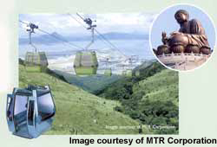
The Lantau cable car system is in the news again. You may remember that the system was closed down indefinitely when a car crashed to the ground during a high-speed test. The inquiry into the accident found that the cause was largely due to management inadequacies. Well, the MTR, which owns the system, has decided to terminate the contract with the management company and run it themselves. It is still not known when the system will open again.
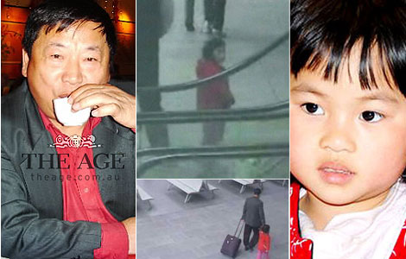
Have you heard about the 3-year old girl nicknamed ‘Pumpkin’? The incident surrounding her has received a lot of attention around the world. She is a Chinese girl from Auckland. Her father took her to Melbourne, abandoned her in a railway station and then flew to Los Angeles. The police gave her the name ‘Pumpkin’ because of a Pumpkin-match jacket she was wearing and the nickname has stuck even when her real name was determined. Over the subsequent days, investigations revealed that the father allegedly murdered his wife and stuffed her in the boot of his car then left NZ. Police in Los Angeles are now on the alert for him. The little girl’s grandmother, who lives in China but is quite close to her, is on her way to NZ (and may be there now). It turns out that the family lived in the Auckland suburb of Mt Roskill, which is where Granddad’s brother, Ernie (Ernest), the father of Wendy and Janice, used to live (I think). The pictures show (a) the father, (b) the pair in the Melbourne railway station, (c) the girl at the foot of the escalator where she was left and (d) Pumpkin herself.
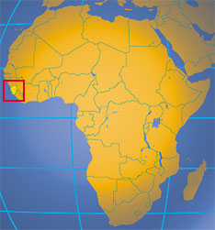
The other night on TV I saw an interesting docudrama on an SAS rescue in Sierra Leone. Until recently, there had been a civil war in the country linked with ‘blood diamonds’ from diamond mines and also linked (I think) to similar problems in neighbouring Liberia. Britain sent its military into Sierra Leone to end the civil war and set up a functioning government, which indeed was very successful and for which the people of the country are grateful. Well, an army patrol was out one day when it was ambushed by one of the rebel gangs and the soldiers held hostage. The programme was about how they were rescued. Interesting. An advance SAS party spent days in the jungle outside the jungle camp, sometimes just 50 metres from it without being detected. The rescue was successful but cost the life of one soldier.

Last Monday, I began to do an O-Level chemistry revision guide for students in Singapore who do a combined chemistry-physics (or biology) course. The book is a slightly simpler version of a similar one for students who do a pure, single-subject chemistry course. I have not been keen on doing them as they are revisions of the books by another original author who died a few years ago so I have to share the royalties which will not be great anyway as they are low-cost productions!

The Rugby world cup continues. Yesterday, South Africa got a big shock when it looked as if they were going to be beaten by tiny Samoa and were only saved when some of the players were replaced by their ‘big guns’. England also beat tiny Tonga and France beat Ireland. The ABs play Scotland today. At this stage, it looks as if NZ will play France in one of the quarterfinals.
Cheers
PS: Leonie (your name by the way, is the same as that used in Sierra Leone) – let me know asap about the queries in my e-mail so I can book accommodation in SFO.

